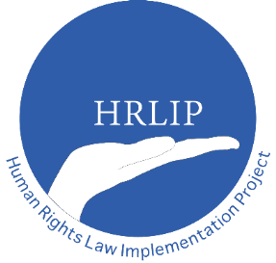
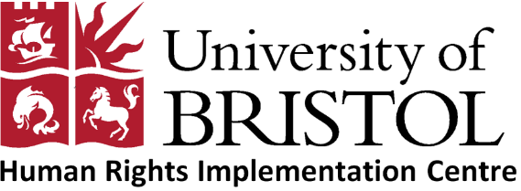

Statement by the Human Rights Implementation Centre to the 60th Ordinary Session of the African Commission on Human and Peoples’ Rights
8-22 May 2017
Item 3: Human Rights Situation in Africa

Honourable Chair,
Distinguished delegates,
The Human Rights Implementation Centre is pleased to participate in the 60th Ordinary Session of the African Commission on Human and People’s Rights, and would like to thank you for the opportunity to address the plenary.
Madam Chair,
An 'implementation crisis' is widely acknowledged to be afflicting regional and international human rights mechanisms which threatens to undermine their integrity and perceived legitimacy. Against this backdrop, regional and international bodies are pursuing efforts to strengthen their mechanisms for ensuring redress for victims of human rights violations and to ensure the swift and effective implementation of their decisions. These efforts adds urgency to a debate which is long-established but remains unresolved: namely what does it mean to implement international and regional human rights law and what factors influence whether States implement or not?

In order to explore this question in more detail, the Human Rights Implementation Centre is working together with the Human Rights Centre at the University of Essex; the School of Law at Middlesex University; the Centre for Human Rights at the University of Pretoria, and the Open Society Justice Initiative to track selected decisions by UN Treaty Monitoring Bodies and the regional human rights bodies against nine Countries in Europe, Africa, and the Americas to see the extent to which the states have complied with them, and why.

Madam Chair,
For our research in Africa we have chosen to track a number of decisions against the States of Burkina Faso, the Republic of Cameroon and the Republic of Zambia. These countries have been chosen as they will enable us to examine implementation of a number of decisions emanating from the African Commission, the African Court, as well as the UN human rights treaty bodies.
Specifically at the regional level our research in relation to Burkina Faso is tracking the following cases from the African Court:
- Lohé Issa Konaté v Burkina Faso (judgment handed down on 5 December 2014)
- Norbert Zongo v Burkina Faso (Judgment handed down on 5 December 2014)
In Cameroon we are tracking the following decisions from the African Commission:
- Jean-Marie Atangana Mebara v. Cameroon (considered in May 2016)
- Mbiankeu v. Cameroon (considered in August 2015)
- Association of Victims of Post Electoral Violence & INTERIGHTS v. Cameroon (considered in November 2009)
- Kevin Mgwanga Gunme et al v. Cameroon (considered in May 2009)
- Annette Pagnoulle (on behalf of Abdoulaye Mazou) v. Cameroon (considered in April 1997)
And for Zambia we are examining the following decisions from the African Commission:
- Legal Resources Foundation v Zambia (considered in May 2001)
- Amnesty International v Zambia (considered in May 1999)
We are currently in the process of interviewing government representatives, litigants, victims, national human rights institutions and civil society organisations on the extent to which each of these decisions has been implemented.
Madam Chair, the Human Rights Implementation Centre welcomes this opportunity to inform the distinguished delegates of this research project and we would welcome information from State representatives and civil society organisations on any measures taken to implement these decisions and provide reparation to the victims.
The Human Rights Implementation Centre and its partner organisations will share with the African Commission and distinguished delegates its findings on completion of the project and we wish to express our willingness to discuss and offer support for the practical application of our research findings at the national, regional and international levels.

Thank you for your attention.

